CP2137

Introduction to Graphics and Artificial Intelligence

Assessment 1
Part 1

Joshua Adam Woodyatt
0622803
Contents

1 State Chart Model of the Herbivore 1
2 State Chart Model of the Carnivore 2
3 Carnivore Source Code 4

State Chart Model of the Herbivore
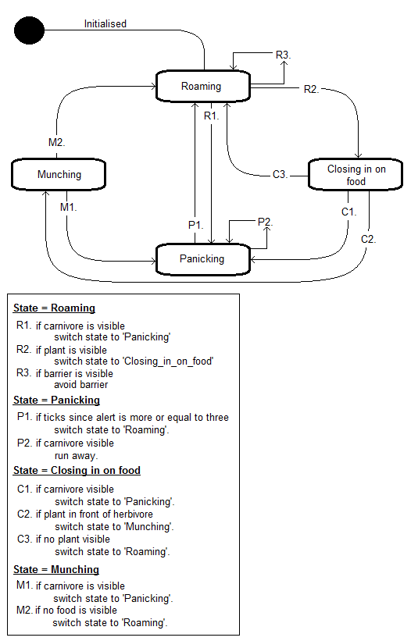

State Chart Model of the Carnivore
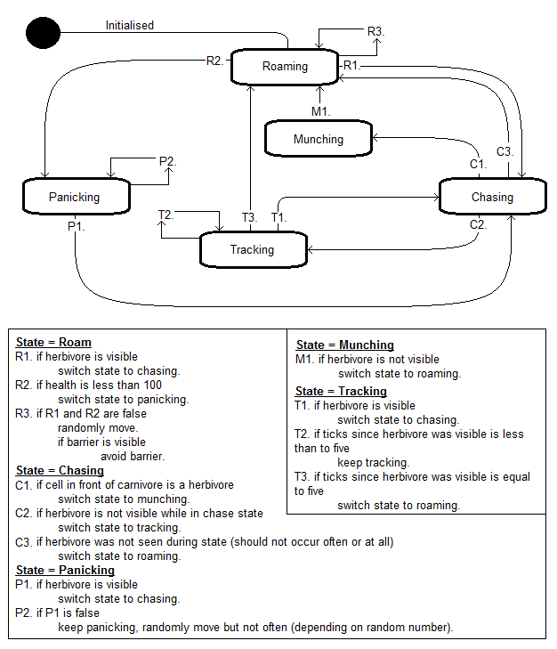

Carnivore Source Code
package hps;

import java.util.List;
/**
* Can you build state machine based behaviour that can make this kind of animal
* a successful predator.
*
* @author Kevan Buckley
* @version 1.0, January 2008
*/
public class Carnivore extends Animal {
/** enumeration State.
* The range of behavioural states that apply
* to the carnivore.
* @param ROAMING
* @param CHASE
* @param MUNCHING
* @param PANICKING
* @param TRACKING
*/
enum State {
ROAMING, CHASE, MUNCHING, PANICKING, TRACKING};

/** enumeration LastSeen.
* The possible directions in which the carnivore
* last saw the herbivore during a chase.
* @param: LEFT
* @param: RIGHT
* @param: CENTRE
* @param: NONE
*/
enum LastSeen {
LEFT, RIGHT, CENTRE, NONE};

/** currentState and previousState used
* to print out changes in state.
*/
protected State currentState = State.ROAMING;
/** currentState and previousState used
* to print out changes in state.
*/
protected State previousState = State.ROAMING;
/** ticksSinceVisible relates to the number of ticks since
* the carnivore lost sight of the herbivore.
*/
protected int ticksSinceVisible = 0;
/** LastSeen lastSeen
* If carnivore loses sight of harbivore it was chasing
* lastSeen records the direction the herbivore was seen.
*/
protected LastSeen lastSeen = LastSeen.NONE;
/** public Carnivore()
* constructor for carnivore.
*
* @param world
* @param row
* @param col
* @param orientation
* @param health = maximum health of carnivore
* @param visibilityRange = maximum distance visible
* @param angleOfVisibility = field of view.
*/
public Carnivore(WorldModel world, int row, int col, in orientation) {
super(world, row, col, orientation);
health = 750;
visibilityRange = 20;
angleOfVisibility = 50; //increased visibility range to improve chase chance
}
/** public void behaviour()
* Main 'running' method, providing state behaviour switching.
*/
public void behaviour() {
if(isDead()){
return; }

// Prints Changes in State
if(currentState != previousState) {
System.out.println("State has changed to: " + currentState);
previousState = currentState;}
/* Sometimes the 'sysos' below will not print when they seemingly
should do. This is due to the fact that health is not just
affected by the above health-- command. Health is also
affected by actions or behaviours in other methods such as
world.charge().
Therefore if the next tick should reduce health to exactly 800
but the during that time another health reducing action is
carried out, the health will not equal exactly 800 upon
returning to this method. These sysos can be removed from
commenting for testing purposes.
*/
/*
if(health == 900) {
System.out.println("health: " + health); } else {
if(health == 800) {
System.out.println("health: " + health); } else {
if(health == 700) {
System.out.println("health: " + health); } else {
if(health == 600) {
System.out.println("health: " + health); } else {
if(health == 500) {
System.out.println("health: " + health);
} else { if(health == 400) {
System.out.println("health: " + health);
} else { if(health == 300) {
System.out.println("health: " + health);
} else { if(health == 200) {
System.out.println("health: " + health);
} else {
if(health == 100) {
System.out.println("health: " + health);
} else {
if(health <= 50) {
System.out.println("health: " + health);
}
}
}
}
}
}
}
}
}
}
*/
decreaseHealth(1);
determineWhichCellsAreVisible();
switch (currentState) {
case ROAMING:
roamingBehaviour();
break;
case CHASE:
chasingBehaviour();
break;
case MUNCHING:
munchingBehaviour();
break;
case PANICKING:
panickingBehaviour();
break;
case TRACKING:
trackingBehaviour();
break;
default:
System.out.println("unexpected state reached"); }

//world.randomMove(this); // this makes the animal wander
//aimlessly
}

/** protected void switchState(State)
* switches old state with previousState
* switches currentState with newState parameter.
*
* @param newState
*/
protected void switchState(State newState) {
previousState = currentState;
currentState = newState;
behaviour(); }
/** boolean justRotated.
* True if carnivore just rotated.
*/
boolean justRotated = false;
/** roamingBehaviour()
* Contains roaming behaviour for the carnivore.
*/
protected void roamingBehaviour() {
ticksSinceVisible = 0;
lastSeen = LastSeen.NONE;
// System.out.println("roaming");
if (isHerbivoreVisible()) {
switchState(State.CHASE); } else {
if (health < 100) { switchState(State.PANICKING);
} else { if (isBarrierVisible()) {
// System.out.println("seen a barrier:");
// printCellList(visibleBarriers);
avoidBarrier(); }
// System.out.println("seen nothing");
if(world.isCellInFrontEmpty(this)) {
world.randomMove(this);
} else if (world.isCellInFrontACarnivore(this)) {
world.randomMoveLR(this);
} else if (world.isCellInFrontAPlant(this)) {
world.randomMoveLR(this); }
}
}
}

/** protected void chasingBehaviour()
* Contains carnivore's chasing behaviour having
* seen a herbivore.
*/
protected void chasingBehaviour() {
// System.out.println("closing in");
ticksSinceVisible = 0;
if (world.isCellInFrontAHerbivore(this)) {
switchState(State.MUNCHING);
} else { if(isHerbivoreVisible()) {
lastSeen = LastSeen.NONE;
headTowardsFood();
} else { if(lastSeen == LastSeen.NONE) {
switchState(State.ROAMING);
} else { switchState(State.TRACKING);
}
}
}
}

/** protected void headTowardFood()
* Contains carnivore's movement behaviour for
* heading toward a visible herbivore.
* Called by chasingBehaviour() and trackingBehaviour().
*/
protected void headTowardsFood() {
//System.out.println("Heading toward food");
if (world.isCellInFrontAHerbivore(this)) {
switchState(State.MUNCHING); } else {
// If this is a new chase.
if(lastSeen == LastSeen.NONE) {
// Produced isNearestHerbivoreDirectlyAhead() method in
Animal class
if (isNearestHerbivoreDirectlyAhead()) {
// System.out.println("nearest herbivore is directly
ahead");
// System.out.println("angle is " +
visibleHerbivores.get(0).getAngle());
world.charge(this);
System.out.println("herbivore was seen to the centre");
lastSeen = LastSeen.CENTRE;
} else {
// Produced isNearestHerbivoreToTheLeft() method in Animal
class
if (isNearestHerbivoreToTheLeft()) {
//System.out.println("herbivore was seen to the left");
world.turnLeft(this);
world.stepForward(this);
world.turnRight(this);
world.stepForward(this);
lastSeen = LastSeen.LEFT; } else {
// Produced isNearestHerbivoreToTheLeft() method in Animal
class
if (isNearestHerbivoreToTheRight()) {
//System.out.println("herbivore was seen to the right");
world.turnRight(this);
world.stepForward(this);
world.turnLeft(this);
world.stepForward(this);
lastSeen = LastSeen.RIGHT;}
}
}
} else {
// if this chase is continuing a previous lost chase
if(lastSeen == LastSeen.CENTRE) {
// if herbivore was last seen ahead
world.randomMoveLR(this);
//world.stepForward(this);
} else {
if(lastSeen == LastSeen.LEFT) {
// if herbivore was last seen to the left
if(justRotated == false) {
world.turnLeft(this);
world.stepForward(this);
justRotated = true;
} else {
world.turnRight(this);
world.stepForward(this);
justRotated = false;
}
} else {
if(lastSeen == LastSeen.RIGHT)
// if herbivore was last seen to the right
if(justRotated == false) {
world.turnRight(this);
world.stepForward(this);
justRotated = true;
} else {
world.turnLeft(this);
world.stepForward(this);
justRotated = false;
}
}
}
}
}
}
}

/** protected void trackingBehaviour()
* Tells carnivore to track herbivore if lost sight of herbivore
* during chase.
* Tracking only continues for five ticks since the herbivore was
* last seen.
*/
protected void trackingBehaviour() {
if(ticksSinceVisible < 5) {
ticksSinceVisible++; }
if(isHerbivoreVisible()) {
//ticksSinceVisible = 0;
switchState(State.CHASE);
} else { if(ticksSinceVisible == 5) {
//ticksSinceVisible = 0;
switchState(State.ROAMING);
} else {
headTowardsFood(); }
}
}

/** protected void munchingBehaviour()
* Contains behaviour for 'eating' chased herbivore.
*/
protected void munchingBehaviour() {
lastSeen = LastSeen.NONE;
// System.out.println("munching");
if (world.isCellInFrontAHerbivore(this)) {
/* eat increases health by 10 points instead of 5.
* This is because if carnivore charges to catch herbivore
* it spends 6 points to catch it so charging to eat
* would have no benefit. Now charging to eat benefits by
* a profit of 4 health points.
*/
world.eat(this);
} else if(isHerbivoreVisible()) {
switchState(State.CHASE);
} else {
switchState(State.ROAMING);
}
}

/** protected void panickingBehaviour()
* Contains behaviour for panicking when health drops below 100.
* The carnivore panics in this way to conserve energy.
*/
protected void panickingBehaviour() {
if(world.isCellInFrontAHerbivore(this)) {
switchState(State.MUNCHING);
} else if (isHerbivoreVisible()) {
switchState(State.CHASE);
} else {
if (Math.random() < 0.90) {
} else if (Math.random() < 0.5) {
world.randomMoveLR(this);
} else {
world.stepForward(this);
}
}
}

/** protected void avoidBarrier()
* Tells carnivore how to avoid a barrier.
*/
protected void avoidBarrier() {
if (isThereABarrierDirectlyAhead()) {
// System.out.println("barrier is ahead, so turning a random
direction");
// Produced this randomMoveLR method in WorldModel
world.randomMoveLR(this);
return;
} else {
world.stepForward(this);
}
}

/** protected void printCellList()
* Prints list of cells.
* @param cells
*/
protected void printCellList(List<EspiedCell> cells) {
for (EspiedCell cell : cells) {
System.out.println("" + cell.getRow() + "," + cell.getColumn()
+ ") d=" + cell.getDistance() + " angle=" + cell.getAngle());
}
}

}

